TEMCARE NOVEMBER 2021 NEWSLETTER

THANK YOU
2021 has been another chaotic year with the COVID pandemic and vaccinations dominating everyone’s conversations. The latest lockdown has certainly challenged everyone, including our clients and staff. Yet despite these challenges, our Heavenly Father has continued to be faithful in enabling us to support some of the most vulnerable members of our community. We could not have done this without your prayer and financial support. And so, thank you and God bless.

SOME RECENT HIGHLIGHTS

Many exciting things occurred during the year. For example, our supporters provided the finances that facilitated the purchase of a laptop for one young person in need, as well as special orthotic shoes for another. In each case, both the parent and the young person were very grateful for the generosity displayed by the donors. The mother of the child who needed the laptop was overwhelmed and could not stop crying, as she informed friends and neighbours about the generosity of God’s people.

Your generosity also meant that we were able to bless our ‘at risk’ adolescent clients with some wonderful ‘care packages’ during September. We always make sure that our clients understand that the donations have come from God’s people so that they can appreciate how our Heavenly Father cares for them through His people. Again, our clients were so grateful for the care shown towards them. It was a special moment for our staff as they delivered the ‘care packages’ to adolescents.

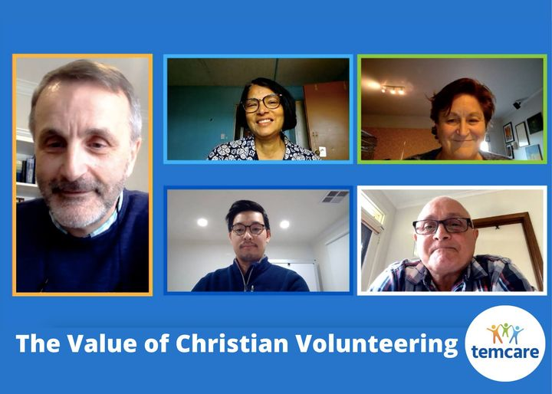
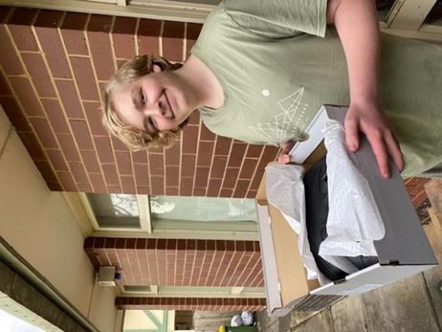
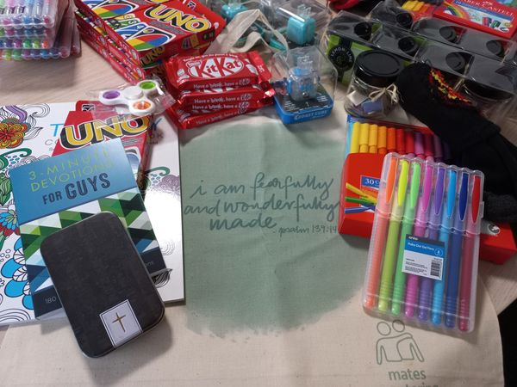

Our special online promotional event on September 4 was a great success, where we were privileged to hear from past and present volunteers and clients. It was exciting and moving to hear how God has used Temcare’s ministries and programs to change the lives of people.

In late October, we put out a call to our supporters, as one of our clients had a very specific need. Her car had broken down and she needed urgent repairs that would cost approx. $6,700; an amount she could not afford. Although we asked our supporters for $3,000, they gave $6,650. This meant that the mother did not have to use funds she had set aside for her children’s school needs in 2022. She was staggered by the response, as were we. As always, we made it clear that the monies came from our Heavenly Father through His people. As always, we made it clear that the monies came from our Heavenly Father through His people.

OUR ONGOING NEEDS

Temcare’s primary focus at the moment is to ensure that we are able to provide the vital services for our clients that they require, particularly following the COVID lockdown. To this end, we recently employed a second youth worker in the MATES program to engage with and assist young people who are struggling with their life challenges. His name is King-Wei Khoi and we are excited to have him as part of our team.

One of our longest serving staff members, Natalie Walton, recently changed her role with us from full-time to part-time. Consequently, we require an experienced and welfare qualified person to work with us for 3 days each week in our Family Services program. The person would be primarily responsible for further developing our ‘Women of Hope’ support group for women, as well as working with other staff in supporting vulnerable families and individuals. At the time of writing, we are still looking for a suitable person.

Most importantly however, we continue to need volunteers to help us build new hope into the lives of those whom God has called us to serve. More specifically, we require committed Christians who are prepared to care for children in our Respite Care program or mentor and support adolescents in our MATES mentoring program.

If you are interested in partnering with us in these important areas, please contact our office on 9877 7729 or office@temcare.org.au You can also find out more about these programs by visiting our website www.temcare.org.au

PARTNERING WITH TEMCARE

We at Temcare desperately need your help to build the future that we believe our Heavenly Father has in mind for this ministry. We therefore need:

- People to pray for our ministry.
- Committed individuals to volunteer as respite carers for children or mentors for adolescents.
- Churches to provide a supportive environment for people in need.
- Donors to financially support the work.

If you are interested in becoming a partner with us, please contact our office on 03 9877 7729 or email us at office@temcare.org.au Alternatively, you can register your interest via our website, www.temcare.org.au

If you would like to financially support Temcare’s ministry, you can do so by making an online donation via our website or by sending a cheque to:

Temcare, c/o P.O. Box 2624, Ringwood North, Vic, 3134.

Direct deposits can also be made to Temcare’s ‘gift account’:

Bank: ANZ
BSB: 013328
ACC: 484168802

All donations over $2 are tax deductible and will be issued with a receipt upon request. In addition, all donations are used to directly support our clients through the various services we provide.

During the forthcoming Christmas school holidays, Temcare will be sending many of our client’s children and adolescents to CYC camps. This is an opportunity for them to hear the gospel and to have a positive social experience in a Christian environment. Many of these clients, including their parents, have thoroughly enjoyed this opportunity and look forward to attending the CYC camps during school holidays.

In addition, we will be running our Family Camp for clients and their children in mid-January 2022, and in late March 2022, we will also be running our MATES mentoring camp for adolescents and their mentors.

If you would like to sponsor a young person to attend a CYC camp or financially support team cares camps, please specify in your donation that it is for this purpose. Your donation will support children, adolescence and mothers to retain these camps and will also assist in the ancillary costs associated with running them.

Thank you for your assistance and support during 2021. We are very grateful for what you have done to support both Temcare and all of the families whom we serve in Jesus’ name. Pease feel free to contact the office if you would like to know anything further. God bless.

Neville Evans, Manager.

